**SQL Training**

### Attention

1. The <XXXX> used in this article represents the employee ID. Please replace it with your own employee ID.

### Create data object

#### Create tables and table indexes

Table ：CUX_OM_CUSTOMERS_XXXX

For storing customer information。

| Field | Type | Nullable | Default Value | Description |
| --- | --- | --- | --- | --- |
|  |  |  |  |  |
| CUSTOMER_ID | BIGINT | N |  |  |
| CUSTOMER_NUMBER | VARCHAR(30) | N |  |  |
| CUSTOMER_NAME | VARCHAR(100) | N |  |  |
| TELEPHONE | VARCAHR(50) | Y |  |  |
| START_DATE_ACTIVE | DATE | Y |  |  |
| END_DATE_ACTIVE | DATE | Y |  |  |
| CREATED_BY | BIGINT | N |  |  |
| CREATION_DATE | DATE | N |  |  |
| LAST_UPDATED_BY | BIGINT | N |  |  |
| LAST_UPDATE_DATE | DATE | N |  |  |
| LAST_UPDATE_LOGIN | BIGINT | Y |  |  |

Create indexes：

| Index | Unique | Field | Description |
| --- | --- | --- | --- |
|  |  |  |  |
| CUX_OM_CUSTOMERS_XXXX_U1 | Y | CUSTOMER_ID |  |
| CUX_OM_CUSTOMERS_XXXX_U2 | Y | CUSTOMER_NUMBER |  |
| CUX_OM_CUSTOMERS_XXXX_U3 | Y | CUSTOMER_NAME |  |

Table：CUX_OM_ITEMS_XXXX

For storing product information。

| Field | Type | Nullable | Default Value | Description |
| --- | --- | --- | --- | --- |
|  |  |  |  |  |
| ITEM_ID | BIGINT | N |  |  |
| ITEM_NUMBER | VARCHAR(30) | N |  |  |
| ITEM_NAME | VARCHAR(100) | N |  |  |
| UOM_CODE | VARCHAR(25) | Y |  |  |
| START_DATE_ACTIVE | DATE | Y |  |  |
| END_DATE_ACTIVE | DATE | Y |  |  |
| CREATED_BY | BIGINT | N |  |  |
| CREATION_DATE | DATE | N |  |  |
| LAST_UPDATED_BY | BIGINT | N |  |  |
| LAST_UPDATE_DATE | DATE | N |  |  |
| LAST_UPDATE_LOGIN | BIGINT | Y |  |  |

Create indexes：

| Index | Unique | Field | Description |
| --- | --- | --- | --- |
|  |  |  |  |
| CUX_OM_ITEMS_XXXX_U1 | Y | ITEM_ID |  |
| CUX_OM_ITEMS_XXXX_U2 | Y | ITEM_NUMBER |  |

table：CUX_OM_HEADERS_XXXX

For storing sales order header information。

| Field | Type | Nullable | DefaultValue | Description |
| --- | --- | --- | --- | --- |
|  |  |  |  |  |
| HEADER_ID | BIGINT | N |  |  |
| ORG_ID | BIGINT | Y | 101 |  |
| ORDER_NUMBER | VARCHAR(30) | N |  |  |
| CUSTOMER_ID | BIGINT | Y |  |  |
| ORDER_DATE | DATE | N |  |  |
| ORDER_STATUS | VARCHAR(30) | Y |  | status list:  UNAPPROVED  APPROVED  CANCELLED  CLOSED |
| DESCRIPTION | VARCHAR(240) | Y |  |  |
| CREATED_BY | BIGINT | N |  |  |
| CREATION_DATE | DATE | N |  |  |
| LAST_UPDATED_BY | BIGINT | N |  |  |
| LAST_UPDATE_DATE | DATE | N |  |  |
| LAST_UPDATE_LOGIN | BIGINT | Y |  |  |
| ATTRIBUTE_CATEGORY | VARCHAR(30) | Y |  |  |
| ATTRIBUTE1 | VARCHAR(150) | Y |  |  |
| ATTRIBUTE2 | VARCHAR(150) | Y |  |  |
| ATTRIBUTE3 | VARCHAR(150) | Y |  |  |
| ATTRIBUTE4 | VARCHAR(150) | Y |  |  |
| ATTRIBUTE5 | VARCHAR(150) | Y |  |  |
| ATTRIBUTE6 | VARCHAR(150) | Y |  |  |
| ATTRIBUTE7 | VARCHAR(150) | Y |  |  |
| ATTRIBUTE8 | VARCHAR(150) | Y |  |  |
| ATTRIBUTE9 | VARCHAR(150) | Y |  |  |
| ATTRIBUTE10 | VARCHAR(150) | Y |  |  |
| ATTRIBUTE11 | VARCHAR(150) | Y |  |  |
| ATTRIBUTE12 | VARCHAR(150) | Y |  |  |
| ATTRIBUTE13 | VARCHAR(150) | Y |  |  |
| ATTRIBUTE14 | VARCHAR(150) | Y |  |  |
| ATTRIBUTE15 | VARCHAR(150) | Y |  |  |

Create Indexes：

| Index | Unique | Field | Description |
| --- | --- | --- | --- |
|  |  |  |  |
| CUX_OM_HEADERS_XXXX _U1 | Y | HEADER_ID |  |
| CUX_OM_HEADERS_XXXX _U2 | Y | ORDER_NUMBER |  |
| CUX_OM_HEADERS_XXXX _N1 |  | CUSTOMER_ID |  |

Table：CUX_OM_LINES_XXXX

For storing sales order line information。

| Field | Type | Nullable | Default Value | Description |
| --- | --- | --- | --- | --- |
|  |  |  |  |  |
| LINE_ID | BIGINT | N |  |  |
| HEADER_ID | BIGINT | N |  |  |
| LINE_NUMBER | VARCHAR(30) | N |  |  |
| ITEM_ID | BIGINT | N |  |  |
| UNIT_PRICE | DECIMAL(10,2) | Y |  |  |
| QUANTITY | DECIMAL(10,2) | Y |  |  |
| DESCRIPTION | VARCHAR(240) | Y |  |  |
| ADDITION1 | VARCHAR(150) | Y |  |  |
| ADDITION2 | VARCHAR(150) | Y |  |  |
| ADDITION3 | VARCHAR(150) | Y |  |  |
| ADDITION4 | VARCHAR(150) | Y |  |  |
| ADDITION5 | VARCHAR(150) | Y |  |  |
| CREATED_BY | BIGINT | N |  |  |
| CREATION_DATE | DATE | N |  |  |
| LAST_UPDATED_BY | BIGINT | N |  |  |
| LAST_UPDATE_DATE | DATE | N |  |  |
| LAST_UPDATE_LOGIN | BIGINT | Y |  |  |
| ATTRIBUTE_CATEGORY | VARCHAR(30) | Y |  |  |
| ATTRIBUTE1 | VARCHAR(150) | Y |  |  |
| ATTRIBUTE2 | VARCHAR(150) | Y |  |  |
| ATTRIBUTE3 | VARCHAR(150) | Y |  |  |
| ATTRIBUTE4 | VARCHAR(150) | Y |  |  |
| ATTRIBUTE5 | VARCHAR(150) | Y |  |  |
| ATTRIBUTE6 | VARCHAR(150) | Y |  |  |
| ATTRIBUTE7 | VARCHAR(150) | Y |  |  |
| ATTRIBUTE8 | VARCHAR(150) | Y |  |  |
| ATTRIBUTE9 | VARCHAR(150) | Y |  |  |
| ATTRIBUTE10 | VARCHAR(150) | Y |  |  |
| ATTRIBUTE11 | VARCHAR(150) | Y |  |  |
| ATTRIBUTE12 | VARCHAR(150) | Y |  |  |
| ATTRIBUTE13 | VARCHAR(150) | Y |  |  |
| ATTRIBUTE14 | VARCHAR(150) | Y |  |  |
| ATTRIBUTE15 | VARCHAR(150) | Y |  |  |

Create Indexes：

| Index | Unique | Field | Description |
| --- | --- | --- | --- |
|  |  |  |  |
| CUX_OM_LINES_XXXX _U1 | Y | LINE_ID |  |
| CUX_OM_LINES_XXXX _N1 |  | HEADER_ID |  |
| CUX_OM_LINES_XXXX _N2 |  | ITEM_ID |  |

#### Import data

excel：《1 – Table Data.xls》

1．CUX_OM_CUSTOMERS_XXXX

2．CUX_OM_ITEMS_XXXX

4．CUX_OM_HEADERS_XXXX

5．CUX_OM_LINES_XXXX

### Questions

#### NO.01

Please create the above objects in the database: table, table index。

#### NO.02

Please import the corresponding table data in the file: "1 – Table Data.xlsx" into the table。

#### NO.03

Create a view：CUX_OM_HEADERS_V

CREATE VIEW CUX_OM_HEADERS_V AS

SELECT

h.HEADER_ID, h.ORDER_NUMBER, h.CUSTOMER_ID, h.ORDER_DATE, h.ORDER_STATUS, h.DESCRIPTION,

h.CREATED_BY, h.CREATION_DATE, h.LAST_UPDATED_BY, h.LAST_UPDATE_DATE, h.LAST_UPDATE_LOGIN,

h.ATTRIBUTE_CATEGORY, h.ATTRIBUTE1, h.ATTRIBUTE2, h.ATTRIBUTE3, h.ATTRIBUTE4, h.ATTRIBUTE5,

h.ATTRIBUTE6, h.ATTRIBUTE7, h.ATTRIBUTE8, h.ATTRIBUTE9, h.ATTRIBUTE10, h.ATTRIBUTE11,

h.ATTRIBUTE12, h.ATTRIBUTE13, h.ATTRIBUTE14, h.ATTRIBUTE15, c.CUSTOMER_NUMBER,

c.CUSTOMER_NAME, c.TELEPHONE

FROM cux_om_headers_46319 h

INNER JOIN cux_om_customers_46319 c ON h.CUSTOMER_ID = c.CUSTOMER_ID;

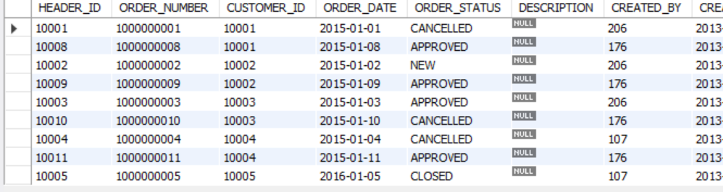

* view：CUX_OM_HEADERS_V

| Field | Type | Nullable | DefaultValue | Description |
| --- | --- | --- | --- | --- |
|  |  |  |  |  |
| HEADER_ID | BIGINT | N |  |  |
| ORDER_NUMBER | VARCHAR(30) | N |  |  |
| CUSTOMER_ID | BIGINT | Y |  |  |
| ORDER_DATE | DATE | N |  |  |
| ORDER_STATUS | VARCHAR(30) | Y |  | status list:  UNAPPROVED  APPROVED  CANCELLED  CLOSED |
| DESCRIPTION | VARCHAR(240) | Y |  |  |
| CREATED_BY | BIGINT | N |  |  |
| CREATION_DATE | DATE | N |  |  |
| LAST_UPDATED_BY | BIGINT | N |  |  |
| LAST_UPDATE_DATE | DATE | N |  |  |
| LAST_UPDATE_LOGIN | BIGINT | Y |  |  |
| ATTRIBUTE_CATEGORY | VARCHAR(30) | Y |  |  |
| ATTRIBUTE1 | VARCHAR(150) | Y |  |  |
| ATTRIBUTE2 | VARCHAR(150) | Y |  |  |
| ATTRIBUTE3 | VARCHAR(150) | Y |  |  |
| ATTRIBUTE4 | VARCHAR(150) | Y |  |  |
| ATTRIBUTE5 | VARCHAR(150) | Y |  |  |
| ATTRIBUTE6 | VARCHAR(150) | Y |  |  |
| ATTRIBUTE7 | VARCHAR(150) | Y |  |  |
| ATTRIBUTE8 | VARCHAR(150) | Y |  |  |
| ATTRIBUTE9 | VARCHAR(150) | Y |  |  |
| ATTRIBUTE10 | VARCHAR(150) | Y |  |  |
| ATTRIBUTE11 | VARCHAR(150) | Y |  |  |
| ATTRIBUTE12 | VARCHAR(150) | Y |  |  |
| ATTRIBUTE13 | VARCHAR(150) | Y |  |  |
| ATTRIBUTE14 | VARCHAR(150) | Y |  |  |
| ATTRIBUTE15 | VARCHAR(150) | Y |  |  |
| CUSTOMER_NUMBER | VARCHAR(30) |  |  |  |
| CUSTOMER_NAME | VARCHAR(100) |  |  |  |
| TELEPHONE | VARCHAR(50) | Y |  |  |

#### NO.04

Write SQL to display the following information and sort it by customer_number and order_number in ascending order。

SELECT

h.ORDER_NUMBER, c.CUSTOMER_NUMBER, c.CUSTOMER_NAME, h.ORDER_DATE, h.ORDER_STATUS, h.DESCRIPTION

FROM cux_om_headers_46319 h

INNER JOIN cux_om_customers_46319 c ON h.CUSTOMER_ID = c.CUSTOMER_ID

ORDER BY c.CUSTOMER_NUMBER ASC, h.ORDER_NUMBER ASC;

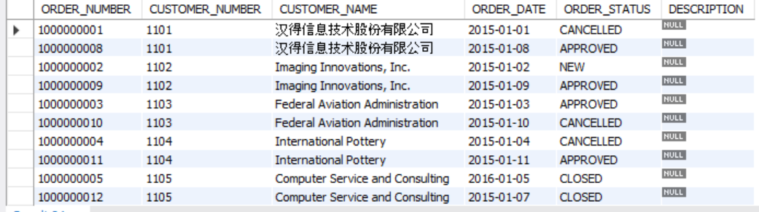

|  |  |  |  |  |  |
| --- | --- | --- | --- | --- | --- |
| order_number | customer_number | customer_name | order_date | order_status | description |
|  |  |  |  |  |  |
|  |  |  |  |  |  |

#### NO.05

Write SQL to display order and order line information, sorted by order number and line number in ascending order (including orders with all statuses)

SELECT

h.ORDER_NUMBER, c.CUSTOMER_NAME, h.ORDER_DATE, h.ORDER_STATUS, l.LINE_NUMBER, i.ITEM_NUMBER, i.ITEM_NAME

FROM cux_om_headers_46319 h

INNER JOIN cux_om_customers_46319 c ON h.CUSTOMER_ID = c.CUSTOMER_ID

INNER JOIN cux_om_lines_46319 l ON h.HEADER_ID = l.HEADER_ID

INNER JOIN cux_om_items_46319 i ON l.ITEM_ID = i.ITEM_ID

ORDER BY h.ORDER_NUMBER ASC, l.LINE_NUMBER ASC;

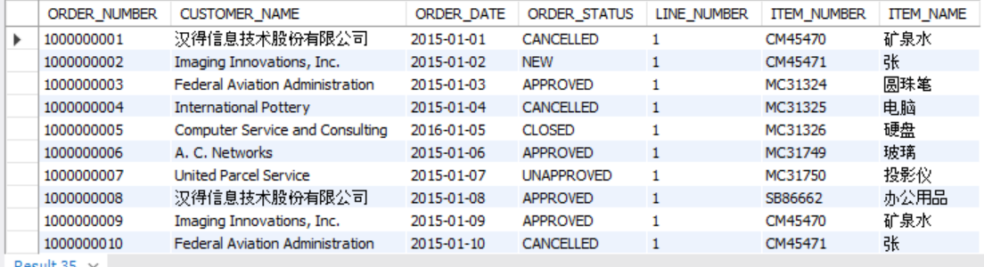

|  |  |  |  |  |  |  |
| --- | --- | --- | --- | --- | --- | --- |
| order_number | customer_name | order_date | order_status | line_number | item_number | item_name |
|  |  |  |  |  |  |  |

#### NO.06

Write SQL to display products purchased by customers

SELECT

c.CUSTOMER_NUMBER, c.CUSTOMER_NAME, i.ITEM_NUMBER, i.ITEM_NAME, i.UOM_CODE

FROM cux_om_customers_46319 c

INNER JOIN cux_om_headers_46319 h ON c.CUSTOMER_ID = h.CUSTOMER_ID

INNER JOIN cux_om_lines_46319 l ON h.HEADER_ID = l.HEADER_ID

INNER JOIN cux_om_items_46319 i ON l.ITEM_ID = i.ITEM_ID

WHERE c.CUSTOMER_NUMBER LIKE '1101';

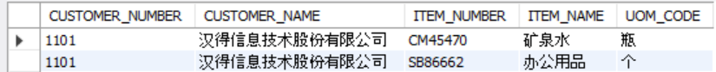

|  |  |  |  |  |
| --- | --- | --- | --- | --- |
| customer_number | customer_number | item_number | item_name | uom_code |
| 1101 | 汉得信息技术股份有限公司 | SB86662 | 办公用品 | 个 |

#### NO.07

Write SQL to count all orders (excluding canceled orders) and calculate the average sales unit price and the highest and lowest unit price by product.

SELECT

i.ITEM_NUMBER, i.ITEM_NAME, AVG(l.UNIT_PRICE) AS AVERAGE_UNIT_PRICE,

MAX(l.UNIT_PRICE) AS HIGHEST_UNIT_PRICE, MIN(l.UNIT_PRICE) AS LOWEST_UNIT_PRICE

FROM cux_om_lines_46319 l

INNER JOIN cux_om_headers_46319 h ON l.HEADER_ID = h.HEADER_ID

INNER JOIN cux_om_items_46319 i ON l.ITEM_ID = i.ITEM_ID

WHERE h.ORDER_STATUS NOT LIKE 'CANCELLED'

GROUP BY i.ITEM_NUMBER, i.ITEM_NAME;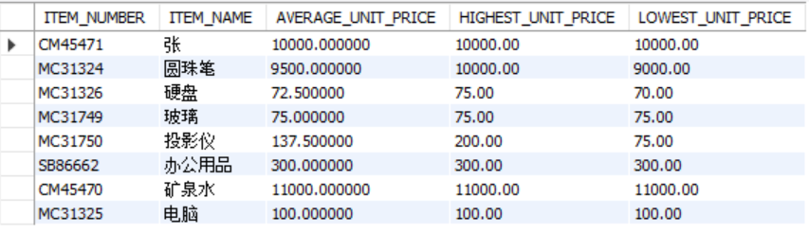

|  |  |  |  |  |
| --- | --- | --- | --- | --- |
| item_number | item_name | average_unit_price | highest_unit_price | lowest_unit_price |
|  |  |  |  |  |

#### NO.08

Write SQL to query customer information about canceled orders.

SELECT

c.CUSTOMER_NUMBER, c.CUSTOMER_NAME, c.TELEPHONE, c.START_DATE_ACTIVE, c.END_DATE_ACTIVE

FROM cux_om_headers_46319 h

INNER JOIN cux_om_customers_46319 c ON h.CUSTOMER_ID = c.CUSTOMER_ID

WHERE h.ORDER_STATUS LIKE 'CANCELLED';

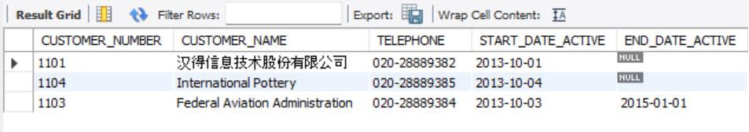

|  |  |  |  |  |
| --- | --- | --- | --- | --- |
| customer_number | customer_name | telephone | start_date_active | end_date_active |
|  |  |  |  |  |

#### NO.09

Write SQL to count the company's total sales in 2015. (All orders with status CANCELLED are excluded from statistics)

SELECT

SUM(l.UNIT_PRICE * l.QUANTITY) AS Total_Sales

FROM cux_om_headers_46319 h

INNER JOIN cux_om_lines_46319 l ON h.HEADER_ID = l.HEADER_ID

WHERE YEAR(h.ORDER_DATE) LIKE '2015'

AND h.ORDER_STATUS NOT LIKE 'CANCELLED';

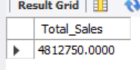

|  |
| --- |
| Total Sales |
|  |

#### NO.10

Write a script to add an index to the table: CUX_OM_ITEMS_XXXX: a normal index, and the applicable field: ITEM_NAME.

CREATE INDEX cux_om_items_46319_N1 ON cux_om_items_46319 (ITEM_NAME);

